Analysis of Gentiana data

**1. Relations between fitness components and reproductive traits - Differences in selection gradients among populations**

Linear models with type II sums of squares.

Fitness components (referred to the median shoot, NOT to the whole plant): using only the number of intact fruits (n_intact_fruits) because number of seeds cannot be calculated accurately for 2011 🡪 relativized to mean = 1 within each population (LokalID).

Reproductive traits: phenology index (phen_index, continuous, varies from 1 to 6, higher values indicate earlier flowering), state of the most advanced bud (most_adv, integer, varies from 1 to 6, higher values indicate earlier flowering), number of flowers (n_fl), number of shoots (n_shoots), height of the median shoot (h_shoot) 🡪 standardized to mean = 0 and sd = 1 within each population (LokalID).

Both measures of phenology (phen_index and most_adv) are strongly correlated (r = 0.86), so cannot include them at the same time in the models.

Removed populations with LokalID = Mar001, Sve001, Sve005 and Sve011 in 2011 because there is no information on fruits. Population with LokalID = Göt016 is colonized by the butterfly from 2010 to 2011.

2010

A) Using phen_index as a measure of phenology

Response: n_intact_fruits

Sum Sq Df F value Pr(>F)

phen_index 0.7 1 0.4126 0.520742

n_fl 334.0 1 207.4691 < 2.2e-16 ***

n_shoots 3.8 1 2.3736 0.123562

h_shoot 11.2 1 6.9753 0.008329 ** Estimate: 0.12448

phen_index:LokalID 89.2 19 2.9155 2.438e-05 ***

n_fl:LokalID 138.6 19 4.5310 2.929e-10 ***

n_shoots:LokalID 37.1 19 1.2138 0.236191

h_shoot:LokalID 35.8 19 1.1706 0.273867

Residuals 3176.4 1973

B) Using most_adv as a measure of phenology

Response: n_intact_fruits

Sum Sq Df F value Pr(>F)

most_adv 0.1 1 0.0476 0.82734

n_fl 296.8 1 185.1523 < 2.2e-16 ***

n_shoots 3.7 1 2.3261 0.12738

h_shoot 12.7 1 7.9045 0.00498 ** Estimate: 0.129928

most_adv:LokalID 103.4 19 3.3950 9.751e-07 ***

n_fl:LokalID 119.8 19 3.9327 2.246e-08 ***

n_shoots:LokalID 35.9 19 1.1783 0.26679

h_shoot:LokalID 37.3 19 1.2245 0.22744

Residuals 3162.8 1973

2011

A) Using phen_index as a measure of phenology

Response: n_intact_fruits

Sum Sq Df F value Pr(>F)

phen_index 6.0 1 2.4571 0.1171974

n_fl 158.9 1 64.9050 1.566e-15 ***

n_shoots 0.2 1 0.0914 0.7624052

h_shoot 0.9 1 0.3840 0.5355609

phen_index:LokalID 61.0 15 1.6616 0.0522906 .

n_fl:LokalID 91.7 15 2.4966 0.0012009 **

n_shoots:LokalID 26.7 15 0.7274 0.7584049

h_shoot:LokalID 95.0 15 2.5876 0.0007627 ***

Residuals 3751.2 1532

B) Using most_adv as a measure of phenology

Response: n_intact_fruits

Sum Sq Df F value Pr(>F)

most_adv 1.2 1 0.4708 0.4927240

n_fl 119.2 1 48.7982 4.215e-12 ***

n_shoots 0.2 1 0.0643 0.7999103

h_shoot 1.1 1 0.4530 0.5009989

most_adv:LokalID 71.5 15 1.9510 0.0155600 *

n_fl:LokalID 102.1 15 2.7845 0.0002795 ***

n_shoots:LokalID 25.1 15 0.6843 0.8022097

h_shoot:LokalID 84.7 15 2.3107 0.0029717 **

Residuals 3746.2 1533

In both years, there are differences in selection gradients for phenology (when using phen_index in 2011 the interaction is marginally significant) and flower number between populations. In 2010, the selection for higher shoots is constant between populations, while in 2011 there are differences between populations in the selection gradients for shoot height.

**2. Differences in selection gradients between populations with/without predator**

2010: 10 populations with predator / 10 without predator

2011: 11 populations with predator / 5 without predator

Selection gradients for each trait and population were calculated as the slope (beta-value) of the relationship between fitness and traits within that population.

A) Using phen_index as a measure of phenology

|  |  |
| --- | --- |
| 2010 | 2011 |
|  |  |
|  |  |

B) Using most_adv as a measure of phenology

|  |  |
| --- | --- |
| 2010 | 2011 |
|  |  |
|  |  |

The selection gradients for phenology were different between populations with and without predator in both years. In populations where the predator is absent there was selection for earlier flowering (higher phen_index or most_adv), while in populations where the predator was present there was selection for later flowering (lower phen_index or most_adv).

In 2011 (but not in 2010), the selection gradients for shoot height were also different between populations with and without predator (coincident with the results of the previous models). In populations where the predator is absent there was selection for higher shoots, while in populations where the predator was present there was selection for lower shoots.

There were not any differences in selection gradients for the other traits (flower and shoot number) between populations with and without predator.

**3. Variation in selection gradients with predation intensity**

A) Using phen_index as a measure of phenology

|  |  |  |
| --- | --- | --- |
| Predation measure | 2010 | 2011 |
| N_eggs |  |  |
|  |  |

B) Using most_adv as a measure of phenology

|  |  |  |
| --- | --- | --- |
| Predation measure | 2010 | 2011 |
|  |  |  |
| N_eggs |  | None of the selection gradients were significantly related to any of the measures of predation intensity in this case. |

Selection gradients for flower number and shoot height are significantly related to interaction intensity measured as mean number of eggs per population (considering the 10 populations where the predator was present) in 2010. Populations with higher intensity of predation (higher number of eggs) show selection for lower number of flowers and higher shoots (should not be the opposite, as butterflies will more easily detect higher shoots?). There is, however, no relation between intensity of predation (measured as mean number of eggs) and selection gradient for phenology. Intensity of predation measured as mean number of predated flowers, fruits and buds did not show any significant relationship with any of the selection gradients for traits.

In 2011, the selection gradient for flower number is only marginally related to interaction intensity measured as mean number of eggs per population (when considering phen_index as a measure of phenology).

**4. Effects of traits on interaction intensity**

(in 11 populations where the predator is present)

2010

A) Using phen_index as a measure of phenology

Response: n_eggs

Sum Sq Df F value Pr(>F)

phen_index 445.1 1 57.0682 8.834e-14 ***

n_fl 970.1 1 124.3873 < 2.2e-16 ***

n_shoots 9.1 1 1.1730 0.2790

h_shoot 1.1 1 0.1444 0.7040

LokalID 2831.5 10 36.3065 < 2.2e-16 ***

phen_index:LokalID 843.8 10 10.8193 < 2.2e-16 ***

n_fl:LokalID 1307.3 10 16.7629 < 2.2e-16 ***

n_shoots:LokalID 75.3 10 0.9651 0.4723

h_shoot:LokalID 49.2 10 0.6314 0.7878

Residuals 8570.8 1099

B) Using most_adv as a measure of phenology

Response: n_eggs

Sum Sq Df F value Pr(>F)

most_adv 525.5 1 61.7037 1.023e-14 ***

n_fl 643.0 1 75.5061 < 2.2e-16 ***

n_shoots 8.8 1 1.0306 0.3103

h_shoot 0.1 1 0.0131 0.9088

LokalID 2548.8 9 33.2563 < 2.2e-16 ***

most_adv:LokalID 780.6 9 10.1849 4.057e-15 ***

n_fl:LokalID 635.3 9 8.2894 5.600e-12 ***

n_shoots:LokalID 80.6 9 1.0517 0.3965

h_shoot:LokalID 53.7 9 0.7011 0.7083

Residuals 8549.8 1004

2011

A) Using phen_index as a measure of phenology

Response: n_eggs

Sum Sq Df F value Pr(>F)

phen_index 490.9 1 57.5277 7.578e-14 ***

n_fl 1114.2 1 130.5807 < 2.2e-16 ***

n_shoots 9.9 1 1.1620 0.2813

h_shoot 1.6 1 0.1922 0.6612

LokalID 2576.0 9 33.5433 < 2.2e-16 ***

phen_index:LokalID 797.9 9 10.3902 1.854e-15 ***

n_fl:LokalID 1163.1 9 15.1453 < 2.2e-16 ***

n_shoots:LokalID 74.5 9 0.9700 0.4633

h_shoot:LokalID 48.6 9 0.6326 0.7698

Residuals 8567.1 1004

B) Using most_adv as a measure of phenology

Response: n_eggs

Sum Sq Df F value Pr(>F)

most_adv 1089.9 1 39.4100 5.029e-10 ***

n_fl 6746.4 1 243.9378 < 2.2e-16 ***

n_shoots 2.1 1 0.0749 0.7844

h_shoot 0.0 1 0.0000 0.9969

LokalID 12722.4 10 46.0021 < 2.2e-16 ***

most_adv:LokalID 1213.9 10 4.3893 4.657e-06 ***

n_fl:LokalID 9014.3 10 32.5943 < 2.2e-16 ***

n_shoots:LokalID 309.3 10 1.1182 0.3448

h_shoot:LokalID 176.7 10 0.6388 0.7812

Residuals 28873.0 1044

In both years, selection on phenology and flower number seems to be in part determined by the intensity of predation.

The relationship between the number of eggs and phenology and between number of eggs and flower number varied among populations.

Variation of the relationship between the number of eggs and phenology among populations:

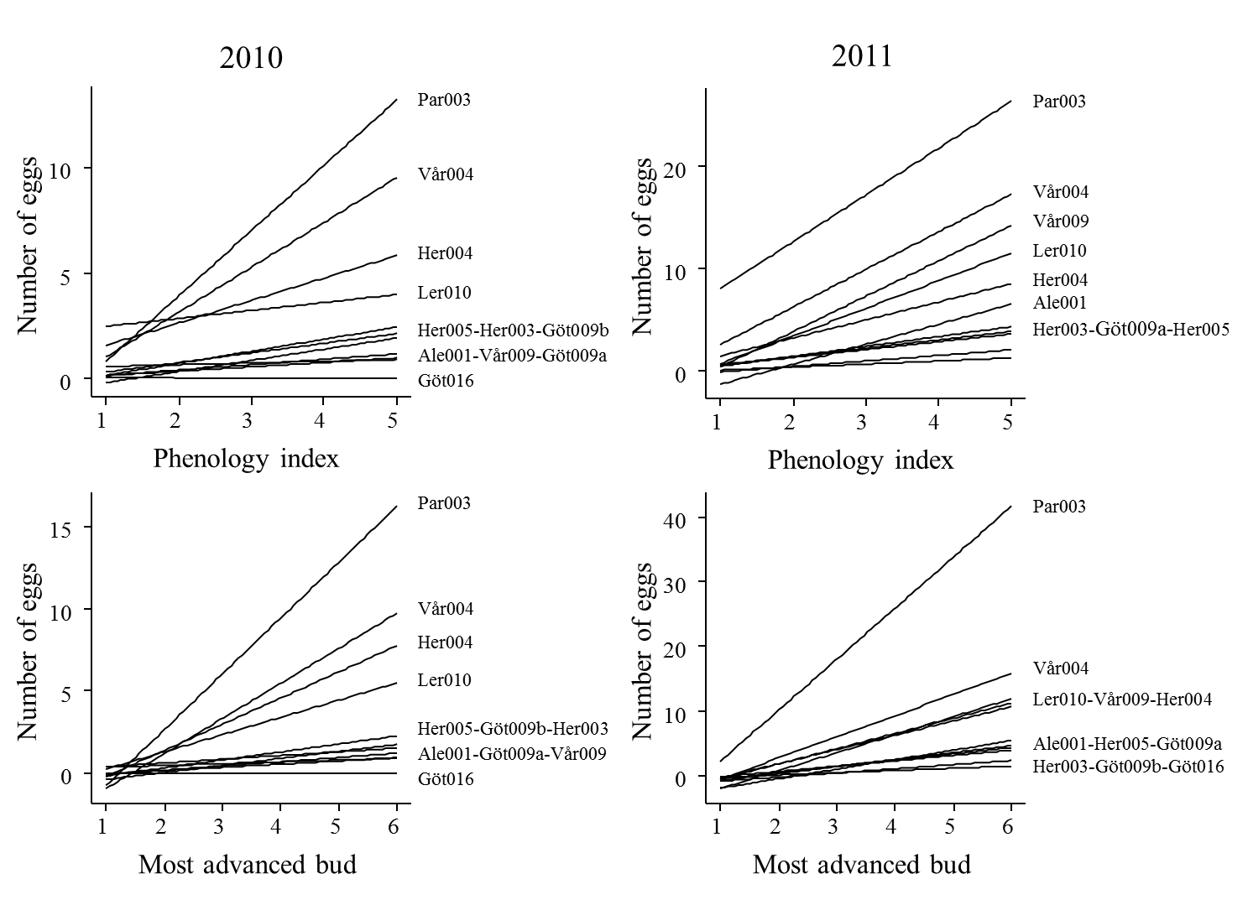

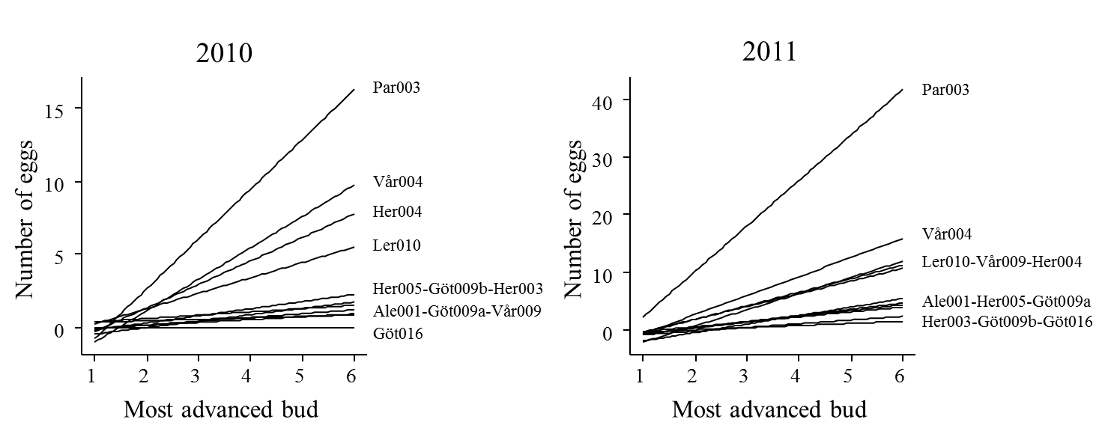

**5. Ants**

|  |  |
| --- | --- |
| 2010 | 2011 |
|  |  |
| Outlier removed |  |

In 2010, there are no significant differences in ant abundance between populations where the predator is present and absent. However, ant abundance is higher in populations where the predator is present and if we remove one outlier (a population, Mar001, with no butterflies but with high number of ants), the differences are nearly significant.

In 2011, populations where the butterfly is present show a significantly higher abundance of ants (even without removing the outlier).

If we use the mean abundance of ants for both years (and remove population Göt016 which changed from predation = 0 to predation = 1), we find a marginally significant difference in ant abundance, which becomes fully significant when removing the outlier.

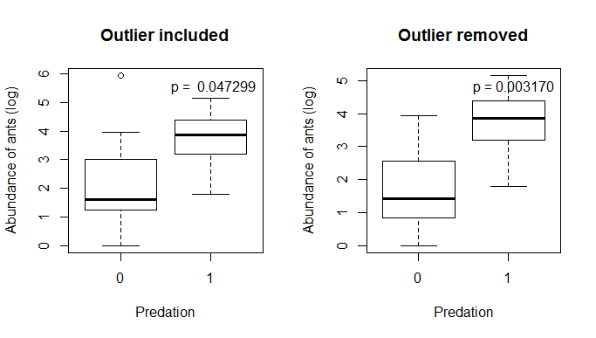

We can also see the effects of ant abundance on predator presence with a logistic regression (maybe more correct?).

|  |  |
| --- | --- |
| 2010 |  |
| 2011 |  |
| Mean 2010-2011 |  |

Abundance of ants in both years is strongly correlated. The population Mar001 is an outlier, with no butterflies but with high number of ants in both years (this population was removed from previous analyses because there were no data on fruits and seeds, but kept here).

In 2010, ant abundance has no effect on the presence of the butterfly.

In 2011, and using the mean ant abundance for both years, there is a significant positive effect of ant abundance on the presence of the butterfly: populations with more ants have a higher probability of presence of the butterfly.

Using the mean ant abundance for both years or the maximum, and including population Göt016 as predation = 1, there is a significant relationship between butterfly presence and ant abundance:

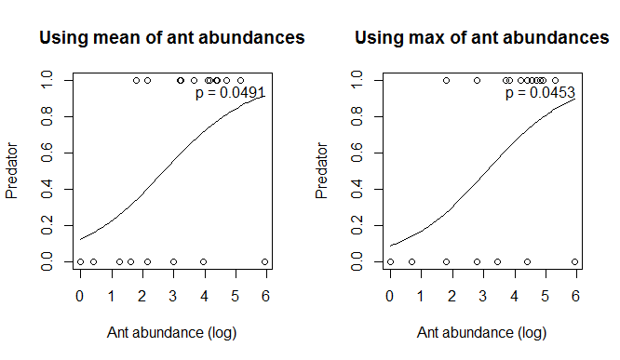

There is also a positive relation with patch area

